Chapter 4-
The Famous “Bowery” Thoroughfare
Creators, Editors, Researchers, & Writers: Christopher Trower, Hudson Spero, Lily Zheng, Matthew Chow, & Melody Chen

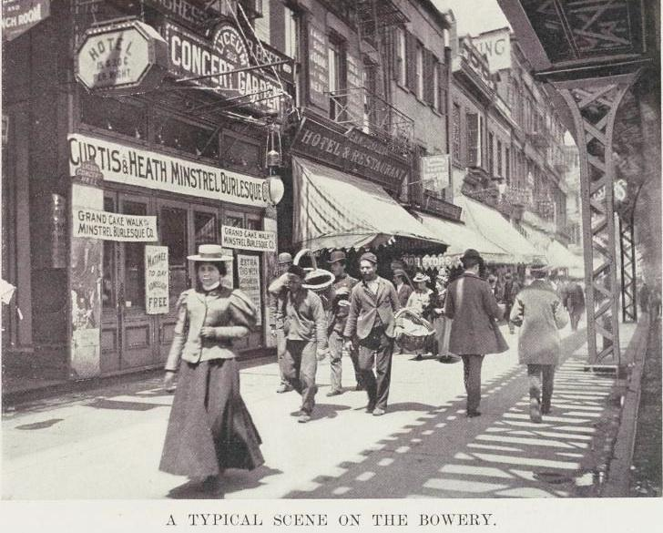
Introduction
The Bowery was the very first thoroughfare in New York City. The street which is a road that forms a route between two places was initially, a Native American footpath. It later linked New Amsterdam and the Dutch Farms, or Bouwerij (the Dutch word for farm) together.
When New York was under British rule, it became part of the Boston Post Road, basically a mail route. The Bowery was originally fourteen blocks long, stretching from Chatham Square to Union Square. Today, it only goes from Chatham Square to Cooper Square, which is about 4th street. The Bowery is also home to the first free slaves. The oldest brick building in Manhattan also resides in the Bowery; #18 Bowery, The Edward Mooney, which was named after a scholar back in the 1800s. The oldest U.S extant building with steel beams is also in the Bowery. But there is much, much more...
Old Lenape Trail-Boston Road and Dutch Farms
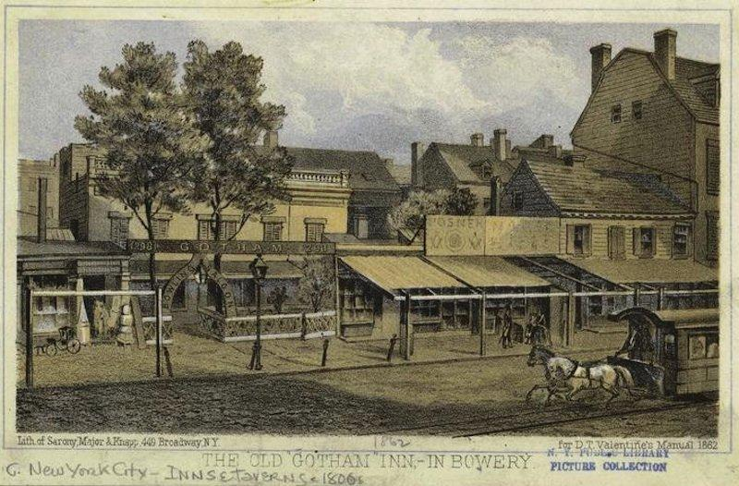
When the Dutch settled on the farms in 1654, they named the Old Lenape Trail Bouwerij, an old Dutch word for "farm", because it connected cattle farms and estates on the outskirts to (what is today) Wall Street. Peter Stuyvesant once lived on these farms. The dutch farms were inhabited by former slaves freed by the Dutch West India Co. According to The Bowery: 400 years on NYC’s Oldest Thoroughfare by the municipal art society of New York, it states, “From flophouses to penthouses, the Bowery has seen it all. Native American footpath, Dutch farm road and site of NYC's first free black settlement, the Bowery was an early social hub for the working class, gangs, gays, immigrant Irish, Italians, Chinese, Jews, and Germans. Stephen Crane called it ‘the most interesting place in New York.’”
On the Dutch Farms, the farmers liked to grow squash, because the large leaves of squash plants shaded the ground. This helps retain soil moisture and prevent weed growth. They also liked to grow corn because corn is easy to grow and pick, while it is easy and cheap to reproduce. During the 19th century, there were little girls known as Corn Girls, who peddled corn in Lower Manhattan to make a living.
BullsHead Tavern - George Washington’s Connection to the Bowery
The Bull’s Head Tavern was located at 50-52 Bowery. After the Bull’s Head Tavern moved uptown, the old tavern became the NY Theater Hotel. George Washington once celebrated a victorious fight against the British in the Bull’s Head Tavern on November 25, 1782. In addition, when George Washington and his troops marched down Bowery after the end of the Revolutionary War, they stopped at the Bull’s Head Tavern to rest and were met by throngs (crowds) of jubilant citizens. The soldiers and the citizens raised their glasses and toasted to the victory before they continued marching further south into the city to celebrate the end of the Revolutionary War. This day is also known as the Evacuation Day. It’s a public holiday that’s celebrated in the United States on March 17th each year. It honors the date when the British troops evacuated Boston during the American Revolutionary War. The tavern was severely damaged in 1845 when the Bowery Theater went up in flames next door.
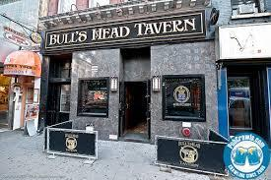
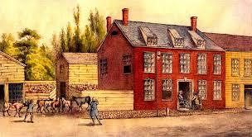

Before
After

Mooney House
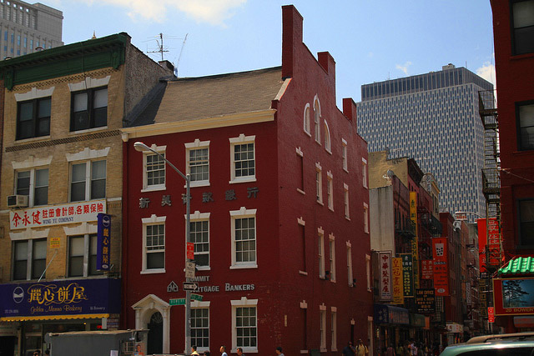
The Mooney House is the oldest brick-house in New York City and it still stands on the Bowery. It is located at 18 Bowery, and was built sometime between British Evacuation and New York’s designation as the nation’s capital (between 1785 and 1789). It was purchased by Edward Mooney, a racehorse breeder and a wholesale butcher. In 1875 from British Loyalist James De Lancey. Edward Mooney used the house for living and it was occupied by him until his death c. 1800 (around 1800, exact date is not known). The architect of the house was unknown, but it’s architecture design contains both pre-Revolutionary Georgian and the new Federal style. The house was used as a private residence until the 1820s after which it has served at various times as a hotel, brothel and saloon. By the 1900s it was Barney Flynn’s Saloon, a hangout for pugilists (boxers), and the base of operations for the Chuck Connors. Now it just stands as an old landmark.

NYC's Oldest Brick House
18 Bowery is now, Summit Mortgage Bankers
Tammany Hall--William “Boss” Tweed
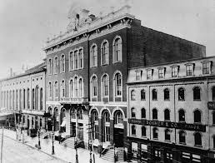
Tammany Hall-
Tammany Hall was a political organization that was created in 1789 to oppose the Federalists. It was an organization that mayors used in their campaign run to try and get more votes. Additionally, the organization shared the same ideas as the local democratic executive committee. Basically, it was an organization that helped the poor immigrant populations, which became really popular because people wanted to get involved in helping them. It was also good for Ward Leaders, leaders in a political party that controls the votes and dictates appointments, because they were now able to support individuals when they had difficulty with the law.
Tammany Hall
William “Boss” Tweed-
However, Tammany Hall wasn’t exactly this perfect political organization. For example, William M. “Boss” Tweed in 1886, was appointed as the leader of Tammany Hall and was elected in the New York Senate. In 1870, he took control of the city’s treasury by passing a city charter, or law, that named them board of audit, a Japanese term for government enforcement. It was ironic that they called themselves this, because they drained the city of its money, handed out fake leases and vouchers, and many other schemes set up in what Biography.com calls, “the Tweed ring.” Tweed wasn’t done though. He wanted more power as leader of Tammany Hall, and so he took control of all Democratic Nominations towards city positions. His power was so strong that he was actually able to elect his candidates as mayors, governors, and speakers of the state assembly. That wasn’t all. He appointed his associates to key city and county posts. However, his reign of power didn’t last forever. In 1873, he was charged with forgery and larceny.
The Bowery Boys
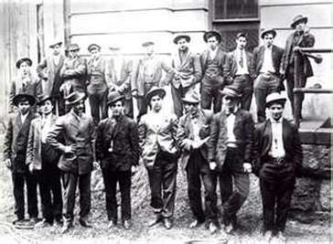
The Bowery Boys were a huge gang of nativists, who were against anyone who wasn’t White American. They fought with immigrants in the area and with the newcomers that arrived. When the Irish arrived in the town neighboring the Five-Points neighborhood, they were resented the most by the Bowery Boys.
On July 4, 1857, this neighboring town was attacked by a whole bunch of Five Points street gangs against this Irish gang called the Dead Rabbits. It sparked a two day battle between these two sides, but in the end, eight people were killed and dozens were injured. Although these gangs often showed lots of gang violence and thuggery, most early gangs were initially created to promote community’s interests or public services, like firefighting.
The Bowery Boys
The Entertainment World
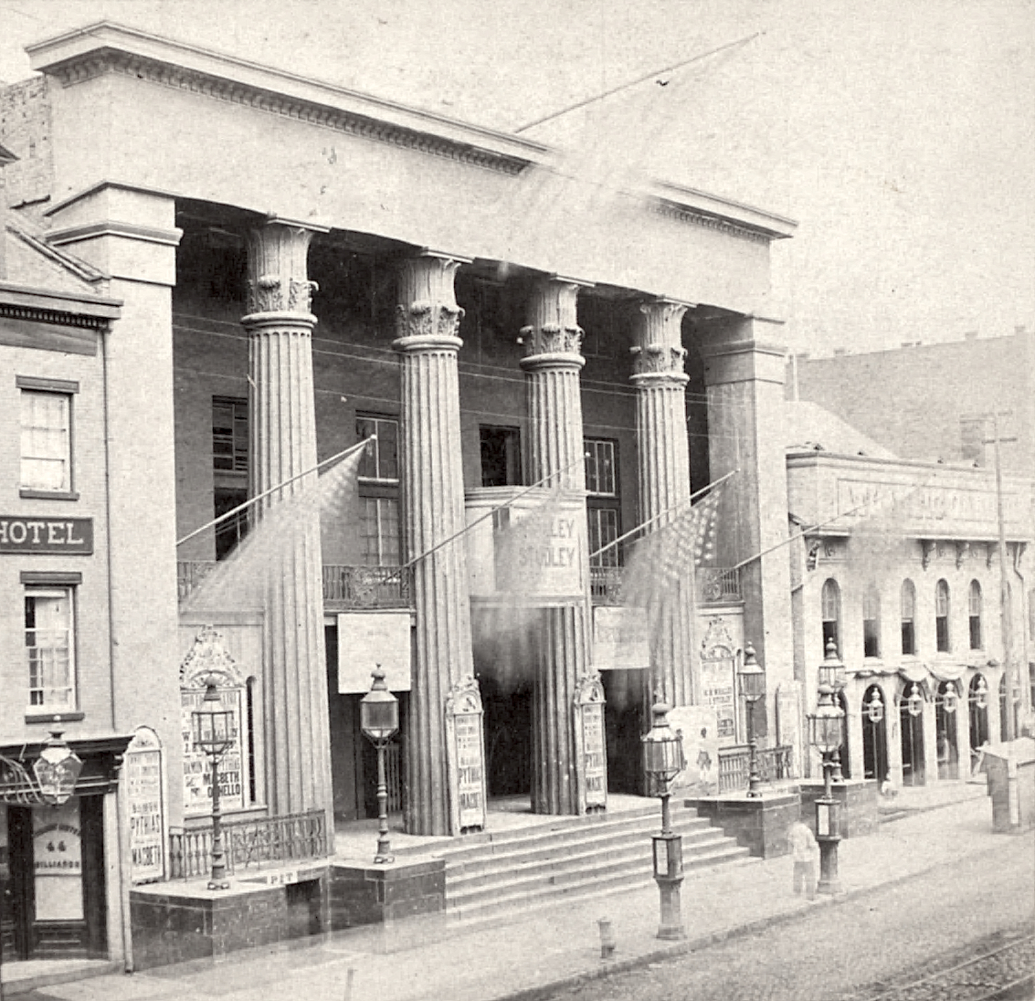
When the Bull’s Head Tavern was sold in 1826, one of the first Bowery playhouse (theater) was built. It was called the New York Theater, later on known as the Bowery Theater. This was the largest theater back then with 3000 seats. Many different types of performances were held here and many famous people came here to watch shows. Some famous people who performed here were Junius Brutus Booth, Charlotte Cushman, Dan Rice, Edwin Forrest, Emma Goldman, Lola Montez, and J.H. Anderson (Chung Ling Soo). Some famous people that came to watch the shows in this theater included our 8th president, Martin Van Buren, when he made a campaign stop in Manhattan while he was running for reelection. The theater burned 6 times but survived for 103 years before officially closing in 1929.
Bowery Theater
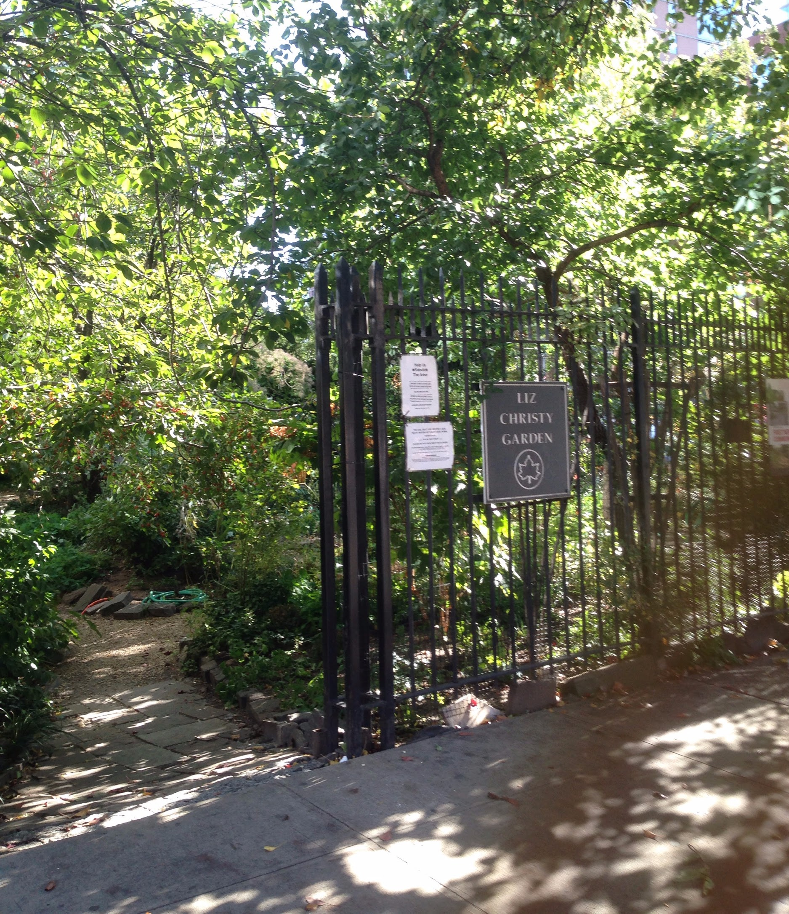
On 319 Bowery, the smallest opera house called Amato Opera opened in 1964. It was founded by Anthony and Sally Amato and the opera house only contained 107 seats. The tickets were sold at really low prices and many grand operas were performed by aspiring young singers. The company was sold and closed at its 61st season when Anthony Amato was 88. In 1973, a vacant lot was transformed into the first New York City Community Garden by artist Liz Christy and some volunteers. It’s now known as the Liz Christy Garden. Throughout many generations, the garden has evolved and many new members are constantly being recruited. The garden maintained its current beauty thanks to the dedication of the volunteers. It once faced the possibility of being demolished due to the growing number of surrounding lots, but thanks to the many actions performed by the supporters of the garden, it not only survived but also managed to expand.
Liz Christy
Community Garden
Conclusion
The Bowery was very controversial to New York City’s beginning. It went from an old native trail, to the Boston Road to where many historic homes and businesses were built and razed. It was where President George Washington and other Revolutionary War heroes celebrated at Bulls Head Tavern and where nativist gangs protected White American culture. It was also where William Boss Tweed created his political machine Tammany Hall and almost made New York City go into debt from his corruption. The Bowery was the first of its kind, and is definitely East Village’s most famous street. The history of the Bowery Street is fascinating, yet not many people bother to learn more about it.

Sources
http://www.neighborhoodpreservationcenter.org/db/bb_files/ED-MOONEY-HOUSE.pdf
http://ontherealny.com/the-edward-mooney-house/
http://www.theboweryhouse.com/history.html
http://daytoninmanhattan.blogspot.com/2014/08/calvert-vauxs-last-work-columbus-park.html
https://www.nytimes.com/2014/09/04/garden/in-his-basement-the-bowery.html?ref=garden&_r=0
http://www.boweryboogie.com/2014/06/tracing-the-origin-of-new-yorks-nickname-the-city-never-sleeps/
http://www.history.com/topics/tammany-hall
http://www.boweryalliance.org/significance-of-bowery/
http://www.businessinsider.com/manhattan-nyc-farmland-photos-20

